Collective sensemaking stories November
In order to reduce inequalities in activity levels there are 3 broad approaches we could take: 1) sector integration, 2) strengthening individual and community capacities or 3) tackling structural inequalities.
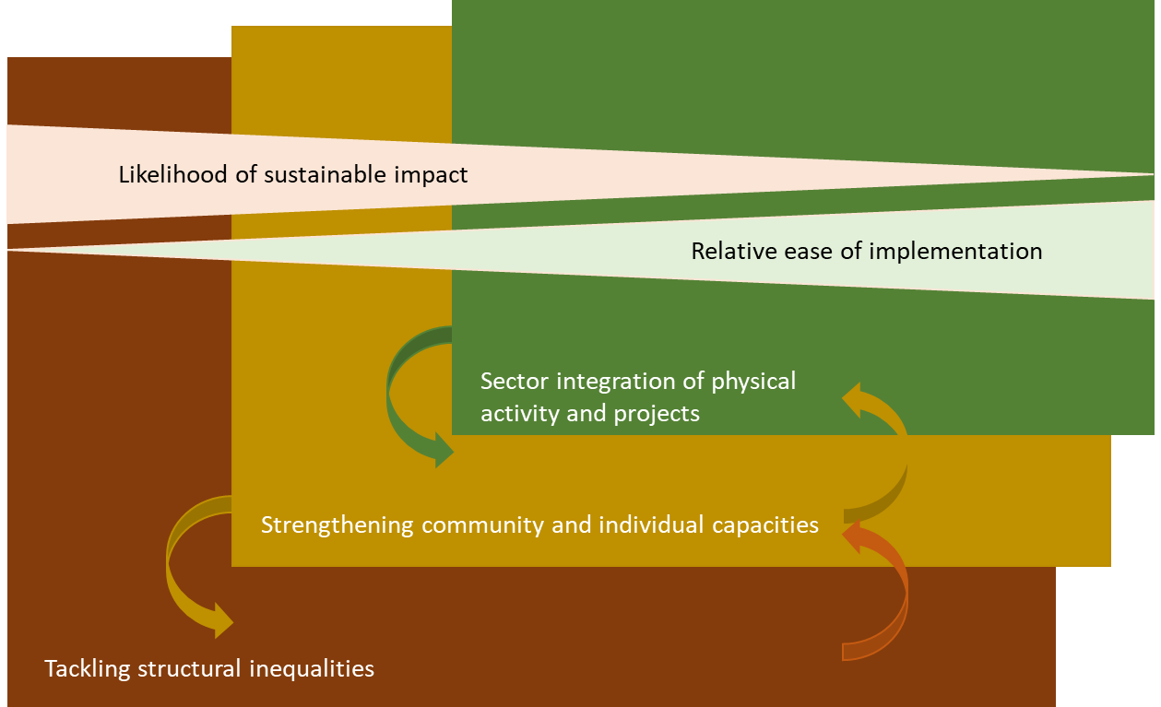
Tendency towards sector integration (green) with regards to the existing evidence and ‘evaluability’. However, pushing the boundary out is more likely to be the most ethical and safeguard against the intervention creating further marginalisation. Here, we share a number of examples across these approaches to bring this work to life.
- Developing Peer Researchers in the LGBTQ+ Older Adults Community
Why?
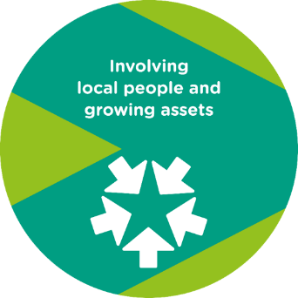
Through involvement in the GM LGBTQ+ Commitment to Inclusion group, our older adults lead identified a need to understand lived experience from the perspective of older adults, as the group was predominantly children and young people (CYP) focused. Although there is research highlighting the health inequalities faced by this community, the understanding of physical activity levels, experiences, barriers and attitudes is limited.

“New analysis, based on data from 24 different surveys, demonstrates that the odds of lesbian, gay, or bisexual men and women experiencing poor self-rated health are around 1.2 times higher than for heterosexual people, with poor self-rated health being a strong predictor of future mortality.” ( ILC (2019) Raising the equality flag - Health inequalities among older LGBT people in the UK)

What?
Our older adults lead is working with the LGBT foundation to reach a community of approximately N older adults from an LGBTQ+ background and our evaluation partner Substance to develop a peer researcher model.
Peer research is a participatory research method in which people with lived experience of the issues being studied take part in directing and conducting the research. It aims to empower people to affect positive change by participating in research on their own communities. At a policy and professional practice layer this involves valuing local and cultural viewpoints and partnering with communities in shared design and stewardship of actions.
So what?
This is an example of how working on something tangible, providing a small amount of investment through our evaluation partner capacity has enabled to start to build a relationship with the older adults lead at the LGBT Foundation who previously struggled to engage.

Through which we will be able to reach ‘less heard’ voices in this community through a trusted relationship, may allow participants to respond more honestly, will develop research capacity and skills for future research, which in turn may add value to this community through increased confidence, self-esteem and social inclusion, and empower a community to invest in their own wellbeing based on the findings of the research, shifting the balance of power.

We are also looking at using a peer research model (using members of the LGBTQ+) community to facilitate the focus groups – if this goes ahead it will open up avenues for further insight gathering at a more micro level (I.e. experiences of older trans men).

Our older adults lead already feels a greater understanding of some of the potential issues facing LGBTQ+ older adults has been improved. Such as exploring community safety and activity levels of LGBTQ+ people pre/post coming out which had not previously identified as potential areas of exploration.

Now what?
Now need to identify areas that we can use this information to influence once the research has been collated and shared across the different layers of the system to ensure that the research allows us to identify and address some of the barriers to older adults being physically active. This could be through training, workshops or other means.

Initially feeding back and connecting internally on opportunities for joint-working, as well as through the Commitment to Inclusion group with wider partners. In particular, share learning about the approach as this develops with our young people equalities lead who is conducting a similar approach with a number of focused youth groups.

- Locally led planning for next steps in the Local Pilot Approach
Why?
Initially the funding distribution for the Local Pilot was determined centrally based on inactivity levels and population sizes in each locality, with 3 target audiences identified (CYP outside of school, those aged 40-60 with a LTHC and those at risk of worklessness. Over the past 3-4 years through an open test and learn approach we have captured copious amounts of learning more formally through 9 process evaluations. However, now in a position where next steps need to be locally informed based on and building on what we have learnt specific to place.
What?
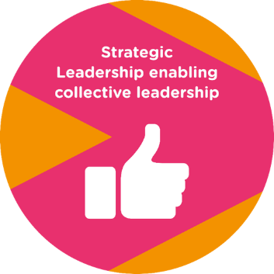
Started conversations across Greater Manchester, to outline how we embed the Local Pilot approach going forwards, and move to a wider place-based approach, which encompasses other work streams such as playzones and pivot to wellbeing. To do this we convened two meetings in July, and have appointed an independent facilitator, to chair individual locality conversations between November – January. This will look at the impact of this approach, how the initial target audiences have been engaged and benefited from this work, and the wider impact on communities moving forwards.

So what?
The conversations will focus around, the difference the pilot has made, on local communities and the local system, what localities would like to continue and the support and resource required to support this in the future.

In a position where locality relationship builders centrally have developed trusted relationships over time and embedded in the contextual understanding, to be able to ask the right questions, in the right place at the right time.

Now what?
By taking all of this information from across the localities, and drawing emerging themes together, to create a GM narrative which can be presented to Sport England. To look at how this approach can move forwards at scale, but based on the needs and wants from a locality. We need to get better at telling the story of the work, in particular the impact for the beneficiaries.

- Together Fund Developing Advocacy and Capabilities in the Community
Why?
The Together Fund panel has been developed to get a more diverse panel that reflects the communities we are trying to impact.

What?
Previous collective sensemaking story around the Together fund here.

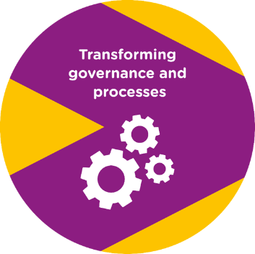
On the together fund, we know that within this financial year alone GS has funded 26 organisations a total sum of £170K. We also know that 20 new organisations tackling inequalities have been funded so far this year.

So what?
Panel members have become advocates for physical activity and funding processes themselves. Working with community groups to upskill application writing for future. This has challenged and stretched Sport England and GreaterSport governance, roles and processes to be more adaptable. And translated this learning for other investment streams i.e. shared at GMCVO.

- Diversifying Recruitment
What?
The diversity of our applicants for all posts recruited to in 2022 is very low. We would like this to increase, which we believe would also have a knock-on effect to the overall quality of applicants we receive. This has led us to consider using a recruitment platform in the future.
So what?
We have analysed the data from the equality forms for our recruitment throughout 2022. This is based on the limited amount of information we requested in the old form, but still gave some interesting insights (examples below):
- 30% of applicants were not White British. 100% (all 8) of staff recruited were White British.
- 59% of applicants were male. 38% were female. 5 staff recruited were female, 3 were male.
- Only 4 applicants disclosed that they had a disability. 4 prefer not to say, 1 didn’t answer, 91 answered no.
- 86% of all applicants were heterosexual.
- 77% of applicants were either Christian or No Religion (40 Christian, 37 No Religion).
- 2 applicants edited the form to include ‘Gay Man’ in the sexual orientation section, rather than use ‘Gay’ that was already in there.
We have now had several demos from various recruitment platforms that all enable better diversity in recruitment (as well as creating better processes in general). This is via recruitment techniques, non-biased language and improved fairer recruitment processes. It is my view that we should use one of these platforms in the future (budget allowing). If not, we can update our current processes from what we have learned during the demos.
Now what?
Analyse findings from the recruitment platform demonstrations and make recommendations to Exec then the Nominations & Remuneration sub-committee.
For any recruitment before the potential launch of a new platform, we will use the new Equality Monitoring form.

https://ilcuk.org.uk/raising-the-equality-flag-health-inequalities-among-older-lgbt-people-in-the-uk/

